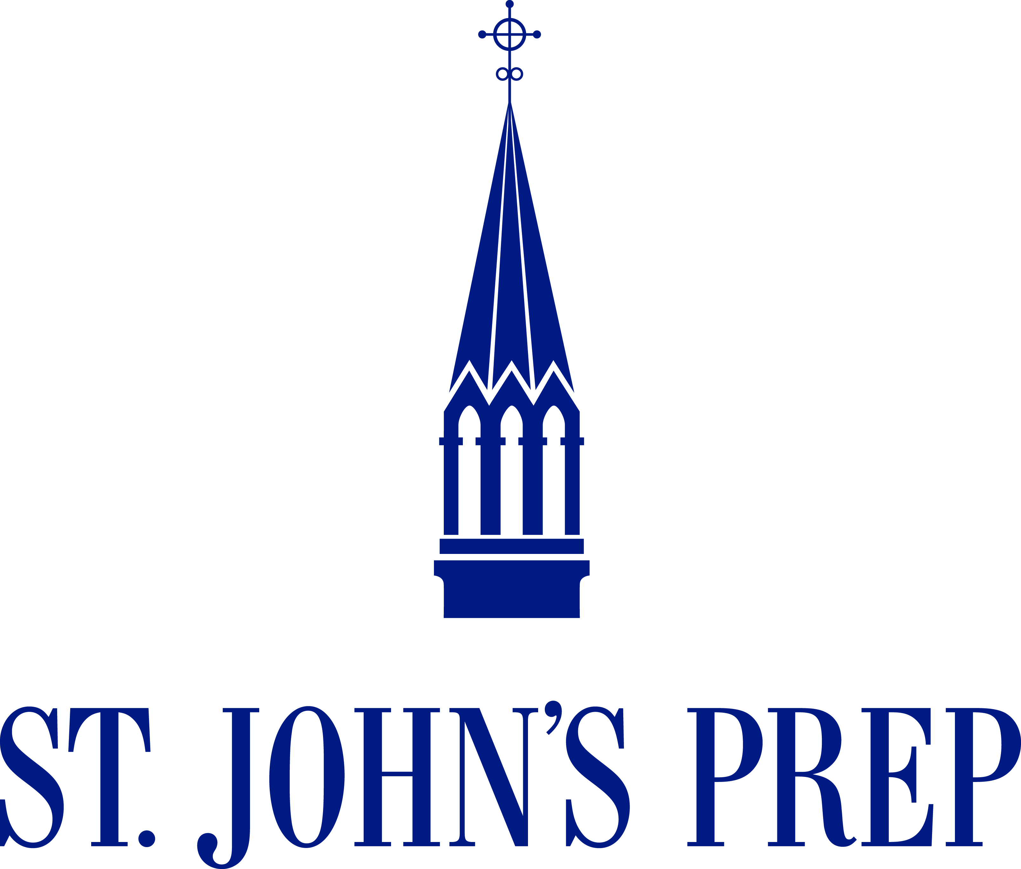
St. John’s  Preparatory School  72 Spring Street  Danvers, Massachusetts  01923  978 774 1050  www.stjohnsprep.org | Learning Coach  St. John’s Prep seeks a committed learning coach who is experienced in working with students and families in grades 6 through 12. The position will report to the Director of the Center for Learning and Academic Success (CLAS). This is a part-time position; candidates must be available to work Monday through Thursday from 12:30 pm to 4:30 pm, and Fridays from 12:30 p.m. to 4 p.m.  Specifically, the learning coach will:  - Provide individual or small group skill-based support.  - Create and implement student workshops and parent webinars.  - Work collegially with school counselors and other members of the faculty / staff to support students and families who access CLAS services.  - Collaborate with the director to ensure the implementation of student success plans.  - Support faculty and staff with implementation of strategies for student success plans.  - Model a commitment to learning and professional growth.  - Relate to and communicate effectively with students, parents, faculty, staff and the school administration.  - Perform other duties as assigned by the director of the Center for Learning and Academic Success.  More information about the Center for Learning and Academic Success can be found at www.stjohnsprep.org/CLAS.  All members of the faculty and staff are expected to give witness to our mission and identity as an inclusive, Catholic, Xaverian Brothers Sponsored School for young men. In concert with faculty and staff responsibilities, St. John’s encourages all members of the faculty to be involved in and to help enhance the life of the school, which includes a wide range of co-curricular, intramural and interscholastic programs.  A bachelor’s degree and teaching experience in a program similar to the Center for Learning and Academic Success at St. John’s is required. In addition, candidates should be team-focused and value professional collaboration.  Interested candidates are asked to submit a résumé and cover letter to Tracii Schaeublin, Director of Human Resources, at tschaeublin@stjohnsprep.org.  Posted March 2017

